**Automotive**

**Insulating**

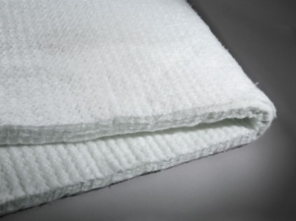

**CERAMIC BLANKET**

DESC: Furnace repair, Boiler linings, Furnace door linings and seals, Reusable insulation for steam and gas turbines, High-temperature kiln and furnace insulation, Primary reformer heater insulation, High temperature gasketing, Glass furnace crown insulation, Field steam generator lining,Thermal reactor insulation,Flexible high temperature pipe insulation, Investment casting mold wrapping,Removable casting mold wrapping, Removable insulating blankets for stress relieving welds, Pressure and cryogenic vessel fire protection.

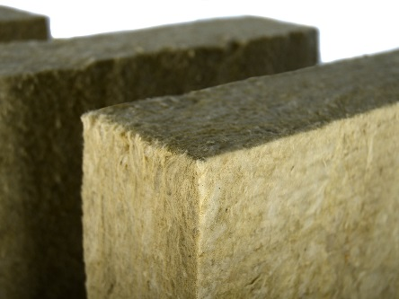

**Rockwool**

lightweight mineral fiber product made from rock-based raw materials, which are designed as sound absorbing and insulation against heat.

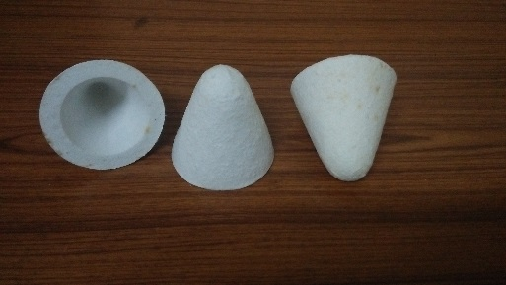

**Tap out Cone**

Tapout cone is used in reverberatory furnace in aluminum melting, It is used to cover & plug tap hole plugs used in furnaces for melting for Aluminum, magnesium & zinc alloys

**Fabricated**

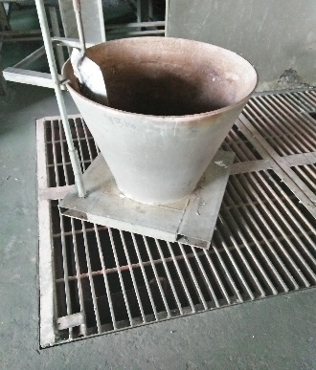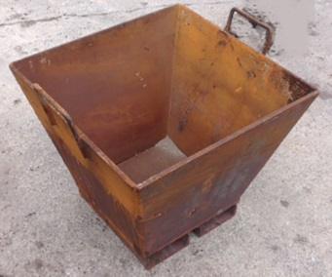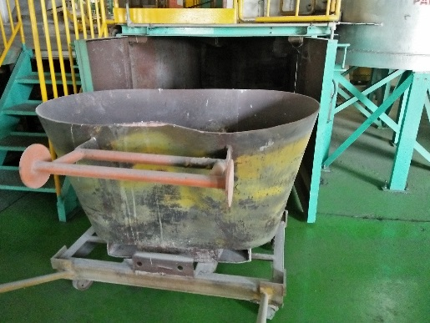

**Dross Oksidasi**

Dross pans, drain pans, sow molds, and related items are helping copper, aluminum.

Size can be customized according to your needs

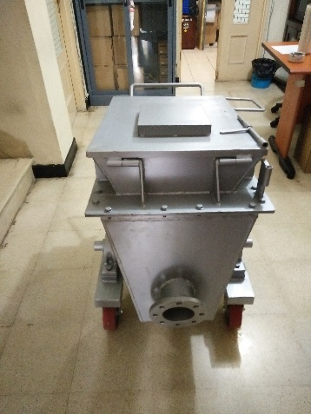

**Distribution Haito**

Size can be customized according to your needs

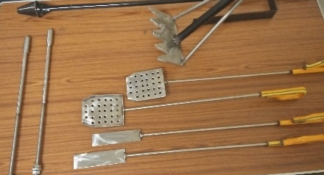

**Tools Melting Area**

We offer all types of Molten Metal Skimmers including, deep dish skimmers, heavy duty skimmers, square skimmers, and other miscellaneous size and shape skimmers for use in molten aluminum and all non-ferrous metals.

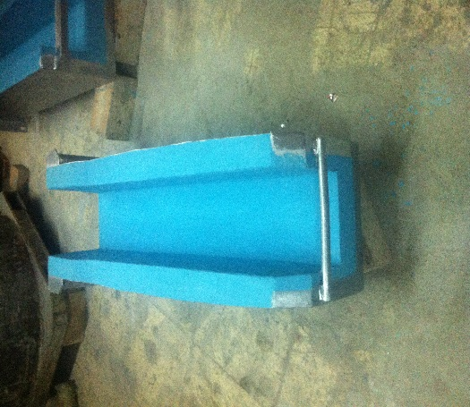**Refractory**

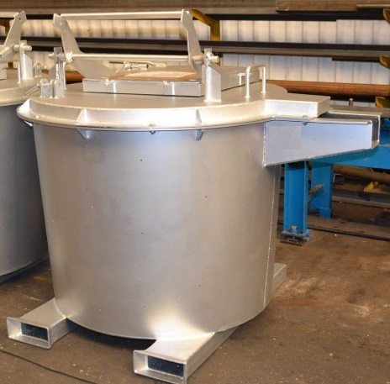

**Ladle Transfer Launder**

ladle transfers are used to transfer hot metals such as steel or aluminum at foundry plants used to transport hot spoons in steel mills. Size can be customized needs.

**Molten Alumunium Filter Die Casting**

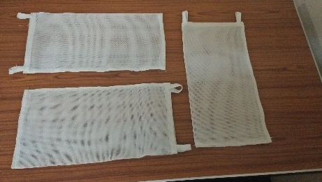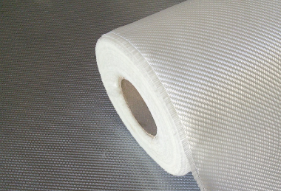

Fiberglass Filtration Filter Bag Filration

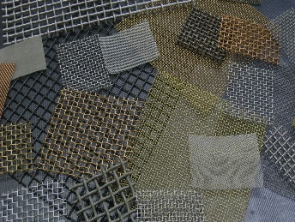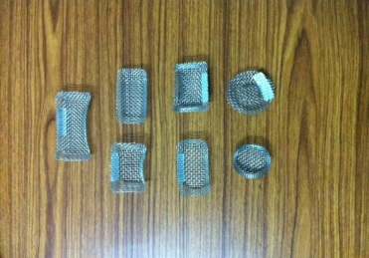

Filter Gate Wire Mesh

Descript:

Fiberglass Filtration

Glass fiber filter media, including fiberglass needle felt and fiberglass woven cloth, because it is high temperature resistant, anti-condensation, dimensional stability, good dust extraction, and high filtration efficiency widely used in metallurgy, cement, power plant, carbon black, boiler coal-fired, chemical industry and waste incineration industry.

Filter Bag Filration

Made from fiberglass, size can be adjusted to the needs

Filter Gate

Made from Wire Mesh, size can be adjusted to the needs.

Wire Mesh

Material Hot Dipped Galvanized, Electro Galvanized

Application Used in Industry, Agricuture, Construction and Mining

**INDUSTRY**

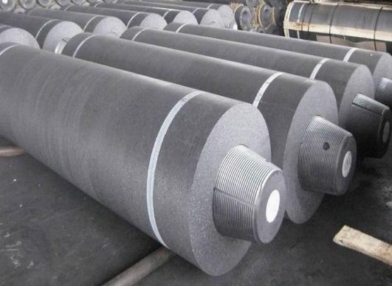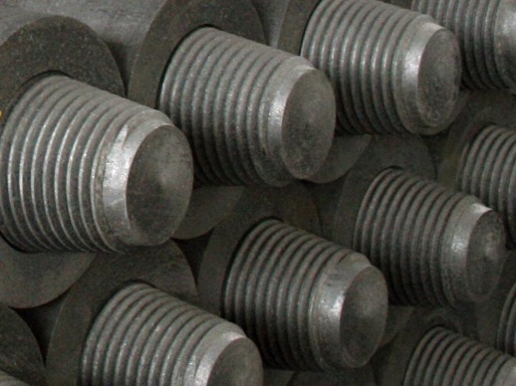

**Graphite Electrodes and Nipples**

Graphite Electrodes and Nipples are composed of carbon compounds because they are made of Petroleum Coke and Coal Tar. Where the two ingredients also come from carbon compounds.

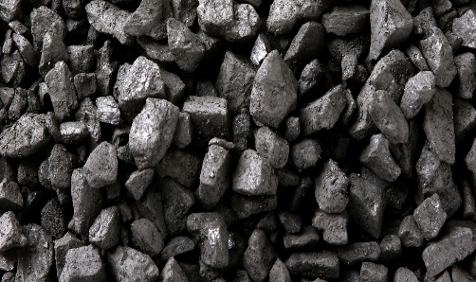

**Coal coke**

Coal coke is a solid material that contains many elements of carbon (C) derived from bitumius / black coal with low levels of ash (ash) and sulfur. This coal undergoes a heating process in a closed chamber with little air without the presence of solvents, catalysts or reagents. Coke derived from coal is usually gray, hard and perforated and has a density of 0.77.

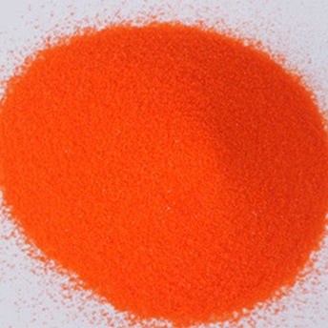

**POTASSIUM DICROMATE**

It's used in manufacturing chromium salt/Mordant dyeing/glass/printing ink/paint/ceramics/lacquer/matches, as oxidizing agent in dyeing and synthetic perfume industry.

**SECURITY SYSTEM**